**Laiba Idrees**

**20F-0281**

**BSSE 7A**

Report: LeadEngines Repository Cloning and Azure Web App Deployment

# Repository Cloning

## Step 1: Cloning LeadEngines Repository

Accessed the LeadEngines repository hosted on [GitHub/GitLab/Bitbucket] using the provided repository URL.

Cloned the repository to a local development machine using Git.

Ensured that all project files and source code were successfully retrieved.

Azure Platform Account Setup

## Step 2: Azure Platform Account Creation

Accessed the Azure Portal.

Created a new Azure platform account by following the account setup process.

Provided the required personal and billing information.

Confirmed the account creation.

Azure Web App Deployment

## Step 3: Creating a Web App Resource

Navigated to the Azure Portal dashboard.

Clicked on "Create a Resource."

Selected "Web App" as the resource to create.

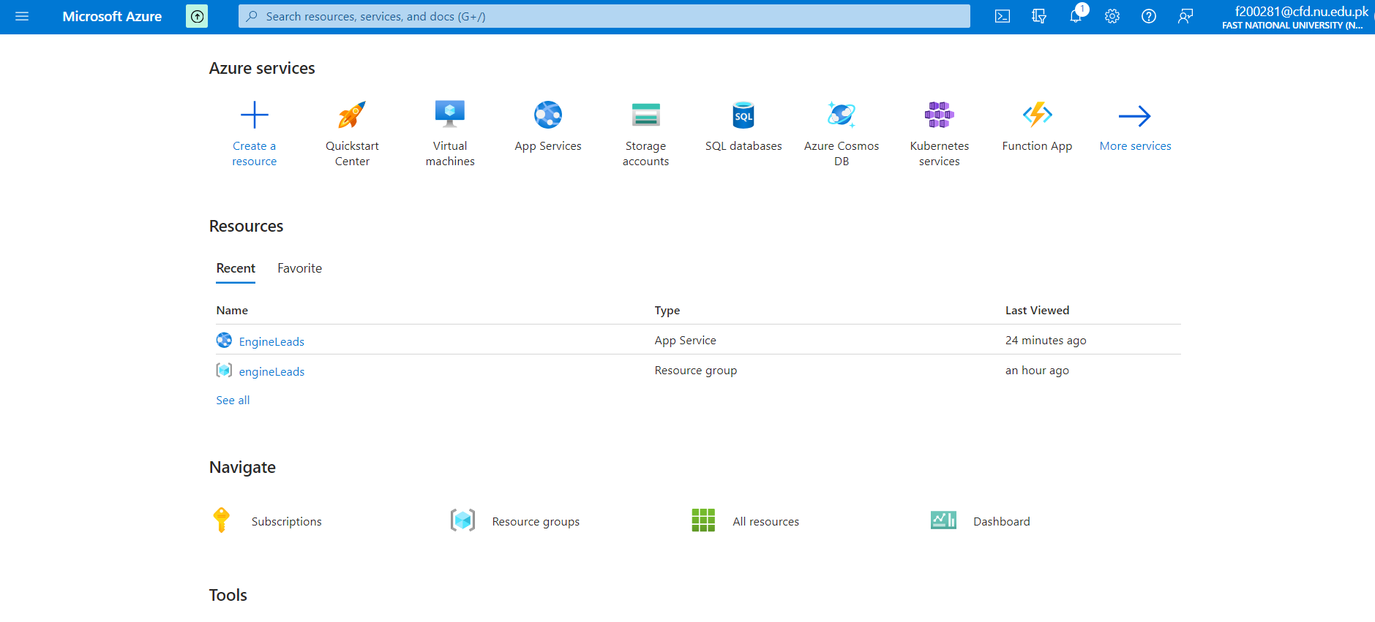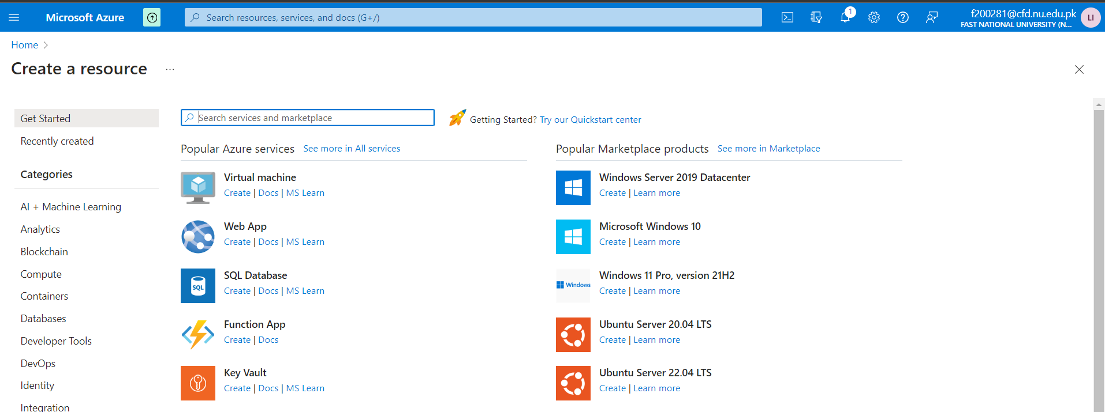

## Step 4: Web App Configuration

Entered a name for the web app.

Chose the "enginelead" resource group for organizational purposes.

Selected the appropriate runtime, which is ".NET 6," for the web app.

Configured the subscription plan (pricing tier) based on project requirements.

Clicked on "Review + create" to proceed.

## Step 5: Deployment

Reviewed the configuration settings to ensure accuracy.

Clicked on "Create" to initiate the deployment of the web app.

Monitored the deployment process in the Azure Portal.

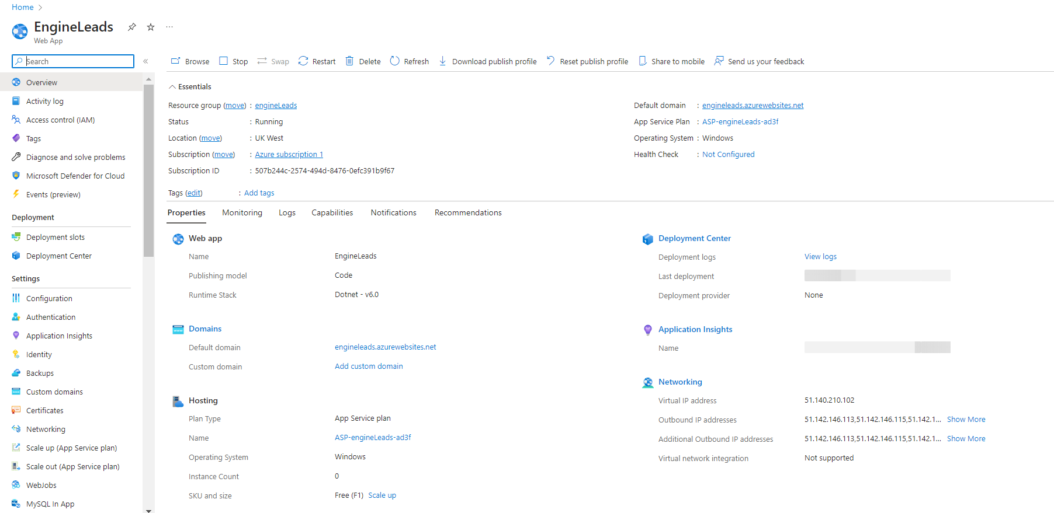

# VS Code Integration and Deployment

## Step 7: VS Code Setup

Opened Visual Studio Code (VS Code).

Installed the Azure extension for VS Code.

Logged in to the Azure account within VS Code.

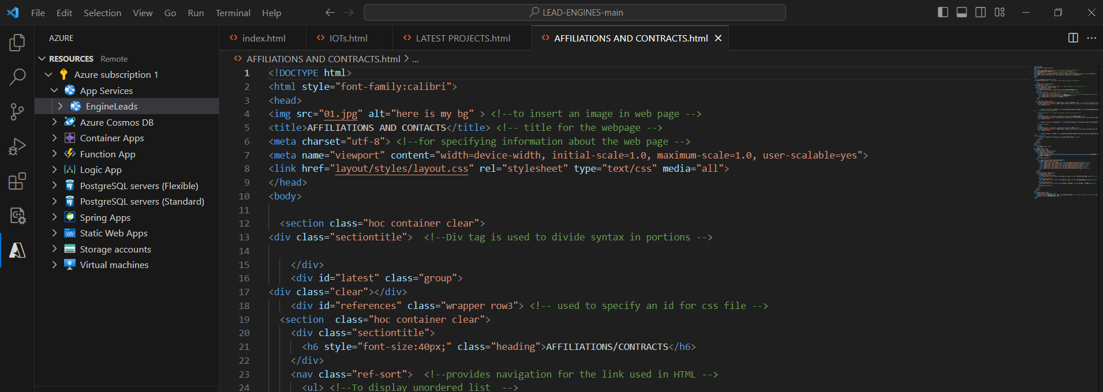

# 

## Step 8: Cloud Deployment

Deployed the web application directly from VS Code to the Azure cloud host.

Monitored the deployment process within VS Code.

Confirmed that the deployment was successful.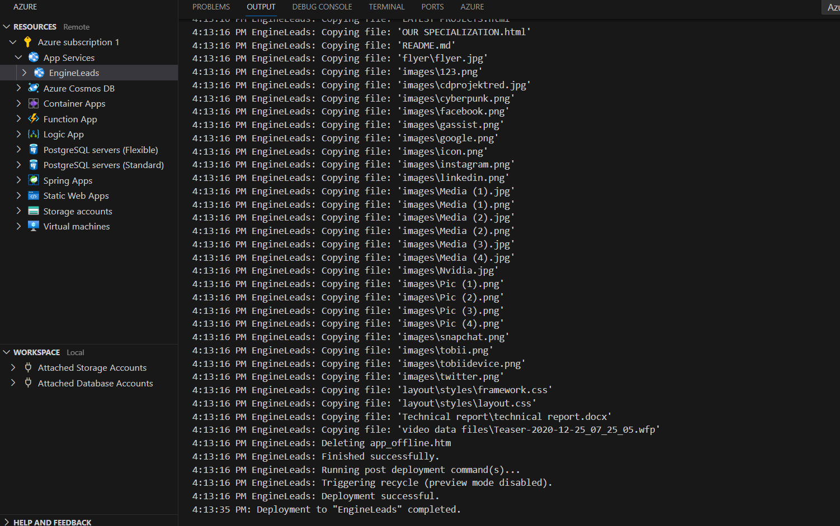

# Conclusion

The LeadEngines repository was successfully cloned, and a web application was deployed to the Azure cloud platform. The deployed web application is accessible at the following URL: https://engineleads.azurewebsites.net/, and it is functioning as expected